**Internal Memorandum**

To: SHUSA Board of Directors

From: Juan Carlos Alvarez, Edward Cipullo

Subject: SHUSA CFP Update Orange Status and RAS Survival Horizon Breach

Date: April 6, 2016

## Executive Summary

## Since our last update to the Board, SC continues to make progress on identified remediation actions and SHUSA prepares the filing of its 10-K, expected April 12th.

## SC’s stock has traded higher during the last 5 trading sessions, closing at $10.57 on April 7th. ABS investors have not raised any material issues with the delayed 10-K filing. Preliminary feedback from rating agencies has been benign but the focus is now on the release of SHUSA’s 10-K.

## Remediation Plan and Funding Initiatives

Actions identified on March 8th to remediate the ACL breach are progressing. As of April 5th the following have been completed:

* + $400mm RBC lease amortizing financing set to close today April 6, 2016.
  + JPM SCARF settled on March 31st for $500mm improving liquidity and the ACL metric for March month end.
  + $1bn WFC (Wells Fargo) revolving subprime warehouse facility renewed for 2 years on 3/31.
  + Citi extended $1.25bn subprime revolver maturing in 2017 into 2018
  + RBC warehouse facility ($400mm Performance Guarantee from SHUSA) now available for funding and in SC’s normal rotation for future activity.

CCART (securitization of Chrysler Capital prime loans) investor meetings kicked off this week with 12 in-person meetings completed as of April 6th. ABS investors have not raised any material issues with the delayed 10-K filing. The expectation is that CCART will be executed next week.

**Next Steps**

On March 30th, SHUSA’s LCMC decided that SHUSA will remain in Orange status until the SHUSA 10-K is filed, expected April 12th. SC is expected to remain in Orange status until the CCART transaction is executed next week. SBNA is expected to remain in Yellow until SHUSA steps down from Orange.

## Before recommending deactivation of the CFP, the LCMC expects SHUSA’s market access and the funding plan to no longer be at risk.

## RAS Metric Breach – SHUSA Survival Horizon

The SHUSA survival horizon is 59 days as of January 2016 month end, one day below the RAS limit of 60 days, and the 90 day liquidity gap is ($2BN). These results are in line with the original glide path remediation plans presented in May 2015 and do not reflect actions taken subsequent to January including $1.5bn in borrowings executed in February 2016. No additional remediation actions are recommended at this time.

SHUSA’s liquidity buffer requirement is driven by SC’s originations under stress. The reason why the January survival horizon has worsened versus December is that the January results capture higher seasonal originations. In addition to our original remediation plan we are working to refine the assumptions that will stabilize and lower the structural liquidity buffer requirement.

The table below shows how the $1.5bn debt issued in February and the improved SC cash flow modeling are forecasted to close the 90 gap to ($.5bn) and improve the survival horizon to above 60 days.

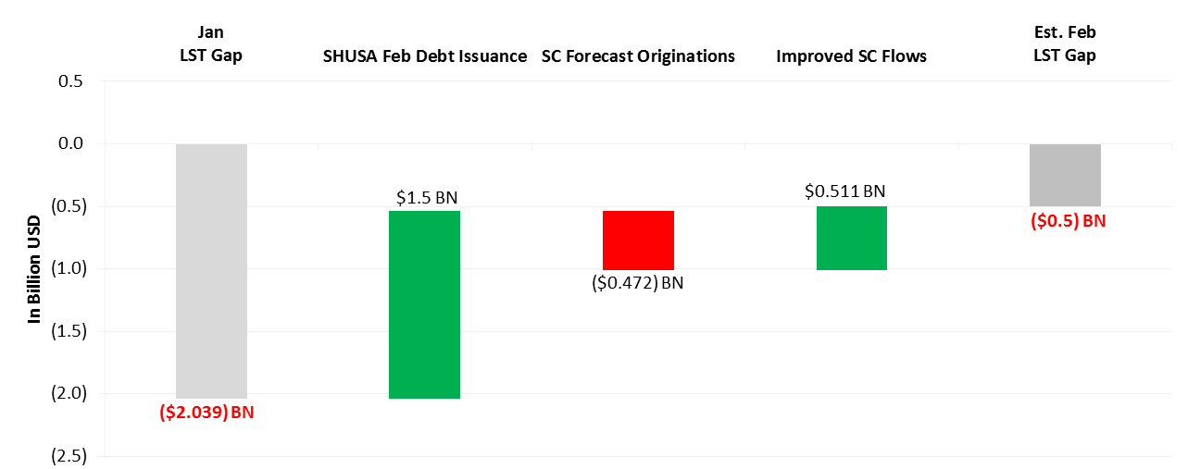

Please do not hesitate to call or send any questions to Juan Carlos Alvarez (+1 617 757 3520) or jalvare1@santander.us ; Edward Cipullo (+1 617 316 3968) edward.cipullo@santander.us